Utah State University

[DigitalCommons@USU](https://digitalcommons.usu.edu/)

[All Graduate Plan B and other Reports](https://digitalcommons.usu.edu/gradreports) [Graduate Studies](https://digitalcommons.usu.edu/gradstudies) 12-2022

The Impacts of a Quagga and Zebra Mussel Infestation

Casey Silva

*Utah State University*

Follow this and additional works at: [https://digitalcommons.usu.edu/gradreports](https://digitalcommons.usu.edu/gradreports?utm_source=digitalcommons.usu.edu%2Fgradreports%2F1689&utm_medium=PDF&utm_campaign=PDFCoverPages)

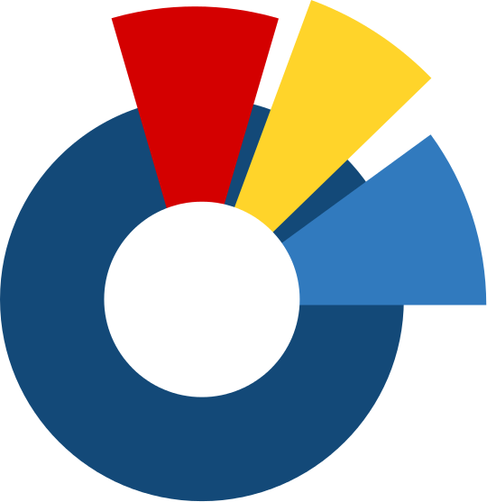 Part of the [Aquaculture and Fisheries Commons](https://network.bepress.com/hgg/discipline/78?utm_source=digitalcommons.usu.edu%2Fgradreports%2F1689&utm_medium=PDF&utm_campaign=PDFCoverPages), and the [Terrestrial and Aquatic Ecology Commons](https://network.bepress.com/hgg/discipline/20?utm_source=digitalcommons.usu.edu%2Fgradreports%2F1689&utm_medium=PDF&utm_campaign=PDFCoverPages)



Recommended Citation

Silva, Casey, "The Impacts of a Quagga and Zebra Mussel Infestation" (2022). *All Graduate Plan B and other Reports*. 1689.

[https://digitalcommons.usu.edu/gradreports/1689](https://digitalcommons.usu.edu/gradreports/1689?utm_source=digitalcommons.usu.edu%2Fgradreports%2F1689&utm_medium=PDF&utm_campaign=PDFCoverPages)

This Report is brought to you for free and open access by the Graduate Studies at DigitalCommons@USU. It has been accepted for inclusion in All Graduate Plan B and other Reports by an authorized administrator of DigitalCommons@USU. For more information, please contact [digitalcommons@usu.edu](mailto:digitalcommons@usu.edu).

THE IMPACTS OF A QUAGGA AND ZEBRA MUSSEL INFESTATION

By Casey Silva

December 7, 2022

A capstone report submitted in partial fulfillment of the requirements for the degree

of

MASTER OF NATURAL RESOURCES

UTAH STATE UNIVERSITY

Logan, Utah 2022

Table of Contents

List of Tables 3

List of Figures 4

Introduction 5

Species Background 6-7

Objectives 8

Methods/Study Locations 8

Utah’s Existing Aquatic Invasive Species Program 8-14

Findings

*Spread of Infestation* 14-18

*Ecological Impacts* 18-20

*Recreational Impacts* 20-21

*Agricultural and Municipal Water Impacts* 22

*Policy* 22-23

*Financial Impacts and Monetary Predications* 23-25

Discussion 25

Literature Cited 26-28

Appendix A 29

Appendix B 29

# List of Tables

Table 1. The vital portions and corresponding section numbers of Administrative Rule R657-60 (Aquatic invasive species interdiction, 2021). 11-12

Table 2. The vital portions and corresponding section number of The Aquatic Invasive Species Interdiction Act (Aquatic Invasive Species Interdiction Act, 2008). 12-13

Table 3. The number of vessels inspected and decontaminated since the introduction of the

UDWR’s AIS program in 2015 (*Inspection Statistics,* 2022). 14

Table 4. Western states and US bodies of water that are currently infested with zebra mussels (Benson et al., 2022(1)). The HUC value is defined as Hydrologic Unit Codes, or how many watersheds are affected by infestation (*Hydrologic Unit Codes (HUC’s) Explained,* n.d.). 16 Table 5. Western states and US bodies of water that are currently infested with quagga mussels (Benson et al., 2022(2)). The HUC value is defined as Hydrologic Unit Codes, or how many watersheds are affected by infestation (*Hydrologic Unit Codes (HUC’s) Explained,* n.d.). 18

# List of Figures

Figure 1. Photo of an adult zebra mussel (Tennessee Wildlife Resources Agency, n.d.). 6 Figure 2. Photo of an adult quagga mussel (Texas Invasive Species Institute, 2014). 7

Figure 3. Comparison photo of adult quagga (left) and zebra (right) mussels (Stop Aquatic Hitchhikers!, n.d.). 7

Figure 4. UDWR’s permanent inspection and decontamination locations. 9

Figure 5. Flow chart of boater interviews for the history of specific vessels. 10

Figure 6. Bodies of water that are currently infested with quagga and zebra mussels (see Appendix A and Appendix B for data amendments) (Benson et al., 2022(1)) and (Benson et al., 2022(2)). 15

Figure 7. The progressive spread of zebra mussels across the United States, broken down by year (Benson et al., 2022(1)). 16

Figure 8. The progressive spread of quagga mussels across the United States, broken down by year (see Appendix B for data amendment) (Benson et al., 2022(2)). 17

# Introduction

Invasive species issues have been on the rise in the United States for decades. These organisms can disrupt the natural flow of an ecosystem and overtake native species, altering an environment as a whole. The introduction of the zebra mussel (*Dreissena polymorpha*) in 1988, followed by the quagga mussel (*Dreissena rostriformis*) in 1989 is arguably the most prolific aquatic infestation the nation is currently up against (Hoddle, 2022). Beginning in the Great Lakes, both quagga and zebra mussels quickly spread their infestations through the Midwest and the East coast. The potential invasion of these species across the West poses the same environmental concerns as the current infestations, though an introduction of quagga or zebra in the western states would affect the economy, residents’ taxes and utility bills, and the agriculture and recreation industries.

At this time Arizona, California, Colorado, and Nevada have multiple bodies of water

with established quagga and/or zebra mussel populations. Utah’s major infestation concern and risk to the rest of the state is Lake Powell, a large reservoir connected to the Colorado River on the Utah/Arizona border. Each state has management procedures and prevention or conservation programs for how to prevent further spread of quagga and zebra mussels, with new technology improving protocols annually.

Utah’s Aquatic Invasive Species (AIS) program goes a step further than the others, positioning the program under the states’ Division of Wildlife Resources (DWR) Law

Enforcement sector. This relationship makes Utah’s AIS prevention measures backed by state law, ultimately giving them a higher compliance rate. Though the DWR does its due diligence to protect these unique and diverse ecosystems, all bodies of water are still at risk of an infestation at any time. Years of data has been compiled on the “what ifs” of this lurking outcome in Utah, yet this information has never been analyzed to its fullest potential or been compared against current infestations in similar environments.

# Species Background

*Zebra Mussel*

The zebra mussel was the initial invader to the Great Lakes. Native to the Black, Caspian, and Azov Seas in Southeastern Europe and Western Asia, these freshwater bivalve mollusks were first observed and documented in 1769. Named for their striped pattern, zebra mussels have dark and light striations and a triangular shell shape with a flattened ventral side (Figure 1). Adult zebra mussels can reach between eight and nine millimeters in width. Reproduction occurs in the water column, with females releasing over 40,000 eggs at a time. These rapid and effective reproduction patterns are one of the key characteristics in zebra mussels’ success at infestation. Once the free-swimming larvae, called veligers, have developed, they begin their juvenile stage at settlers. Settlers begin to sink and search for a suitable benthic environment to attach to. Using byssal threads the adult mussels can attach to any hard substrate, such as rocks, pipes, crayfish, and any artificial surface they deem fit. As settling proceeds, zebra mussels can form colonies as dense as 700,000 individuals per meter squared. These organisms stay attached to the same surface for the remainder of their life span, filtering up to a liter of water per day to feed on algae and phytoplankton in the water column (Benson, et al., 2022

(1)). Zebra mussels have little to no natural predators in the United States and can survive an alarming array of conditions. They have survived temperatures above 120°F and exposure to commercial grade bleach. Rapid reproduction, high filter feeding rates, attachment strategies, and resilience are what make zebra such a nuisance to native ecosystems.

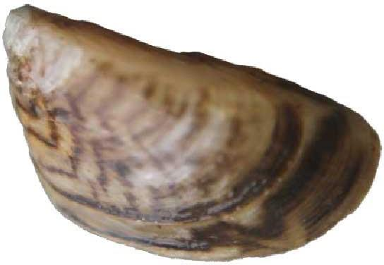

Figure 1. Photo of an adult zebra mussel (Tennessee Wildlife Resources Agency, n.d.).

*Quagga Mussel*

The quagga mussel was first discovered in 1897 and is native to the Dneiper River in Ukraine and the Caspian Sea. Quagga are also freshwater bivalve mollusks and have a rounded shell and convex ventral side whose color patterns can vary between black, cream, and white (Figure 2). Often mistaken for the zebra mussel and vice versa, the quagga mussel is the more tenacious of the two species (Figure 3). Adult mussels can grow up to 4 centimeters, much larger than zebra mussels. The lifecycle of quagga is almost identical to that of the zebra mussel, beginning as free-floating veligers, transforming to settlers, then attaching to hard substrates for the remainder of their lives. In many areas that were once populated with zebra colonies, the quagga mussel has taken over. Quagga mussels share the same temperature and chemical resilience as zebra mussels. Their accelerated reproduction rates, growth rates, and filtration rates, allow them to outcompete zebra mussels for space and nutrients (Benson et al., 2022 (2)).

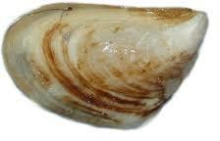

Figure 2. Photo of an adult quagga mussel (Texas Invasive Species Institute, 2014).

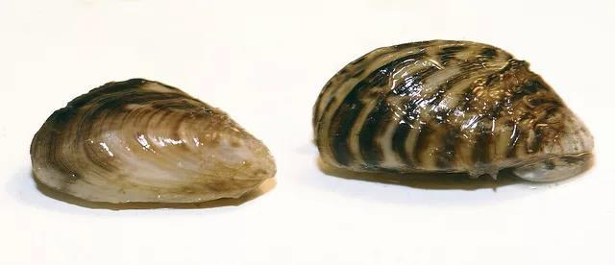

Figure 3. Comparison photo of adult quagga (left) and zebra (right) mussels (Stop Aquatic Hitchhikers!, n.d.)

# Objectives

This study aims to provide a complete picture of the economical, recreational, agricultural, and environmental risks a quagga or zebra mussel infestation poses to the state of Utah. Financial information from currently infested states will be analyzed to paint a picture of what Utah’s economy could be facing if an infestation arises. This data will also be used to display the potential impacts to Utah’s recreation and agriculture industries, what many residents rely on for income throughout the seasons. Law enforcement initiatives, state administrative code, and developing technology in the battle against quagga and zebra will be

explored and discussed. Lastly, the ecological repercussions of an infestation will be researched in relation to water quality, native fisheries, and aquatic vegetation.

# Methods/Study Locations

Though data will be discussed from various states’ protocols, budgets, and mussel research, emphasis will be placed on Utah’s AIS initiatives and risks that pertinent bodies of water face, such as those used for municipal and agricultural water. Field data in the form of boater interactions with agency personnel, statistics from the “Watercraft Inspection and Decontamination Database”, and documentation from law enforcement has been collected annually since the conception of the AIS program in Utah. This information will be used to gain an understanding of boater participation, compliance trends, and public understanding of state protocols. This data will be studied in conjunction with statistics from neighboring agencies, annual state reports, federal invasive species reports, and information from the United States Geological Survey’s (USGS) Nonindigenous Aquatic Species Database. ArcPro will be used to map current infested bodies of water and show the progressive spread of quagga and zebra mussels across the United States since 1986.

# Utah’s Aquatic Invasive Species Program

The Utah Division of Wildlife Resources (UDWR) houses the AIS program under law enforcement and has been a pioneer in the invasive species world since it’s development in 2015. The UDWR splits the state into 6 regions: Northern, Northeastern, Central, Southern,

Southeastern, and Lake Powell South (Wahweap). The state has a total of 46 permanent inspection and decontamination locations. A hot water decontamination, performed at 140°F, has proven to be the only method that ensures quagga and zebra mussels at all stages of life are killed (Utah Division of Wildlife Resources, 2022).

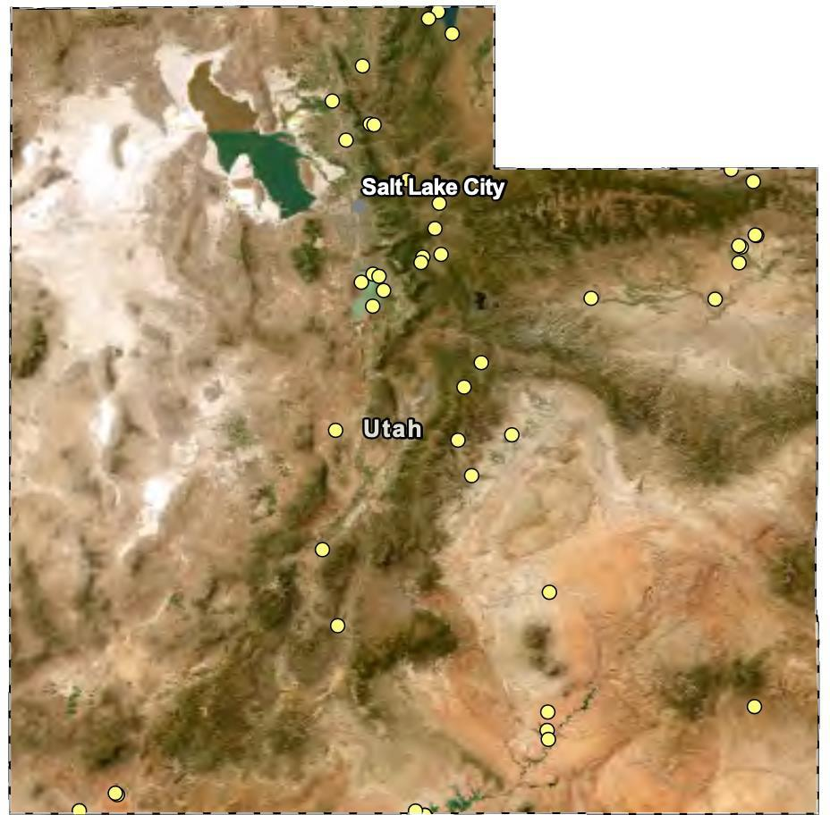

Data Credits: ESRI, UDWR Author: Casey Silva

Figure 4. UDWR’s permanent inspection and decontamination locations.

Each region employs a sampling biologist, an interdiction specialist, and a corporal in the form of a conservation officer. The interdiction specialist and corporal organize and manage boat inspection and decontamination stations at waterbodies and ports of entry in their respective regions. The sampling biologists monitor potential infestations through plankton net surveys and eDNA testing of water samples.

When a boater arrives at an inspection station, they are interviewed by an invasive species technician who questions them on where the boat was last launched or if it’s traveled out of state in the last 30 days. Utah contains only one infested body of water, Lake Powell, so

the majority risk to Utah waters comes from tourists. While performing the interview, the technician enters the bow number of the vessel into the Watercraft Inspection and Decontamination Database for verification on where the vessel was last recorded. The vessel is then inspected for any visible standing water, plant matter, or organisms. Depending on the findings of the inspection and interview, further action such as a decontamination may be required (Figure 5). This process happens at all waterbodies operating prevention programs, meaning programs that are defending the location from infestation.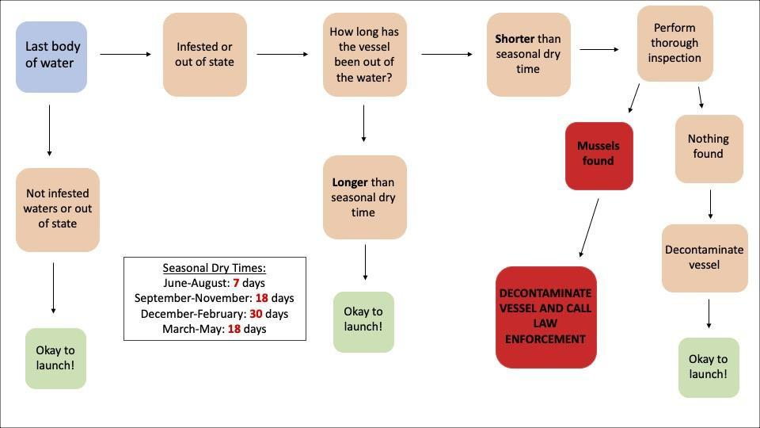

Figure 5. Flow chart of boater interviews for the history of specific vessels.

Lake Powell operates a containment program. Vessels leaving Lake Powell are a threat to all non-infested bodies of water. When a vessel leaves, it is recorded in the Watercraft Inspection and Decontamination Database with a date/time stamp. The boat owner has the option of receiving a decontamination before he leaves Lake Powell or receiving just an inspection to ensure there are no attached mussels. If the boat owner only receives an inspection, the vessel must meet a seasonal dry time or have a decontamination performed at a

later date before it is able to launch again. This record will be shown any time the bow number of the vessel is searched in the database, alerting the technician at the next body of water the level of risk the vessel poses.

The program’s law enforcement status boosts compliance among the general public more than other states. Conservation officer presence at inspection and decontamination stations reinforces the importance of this program to the public. The state of Utah recognizes the severity of a quagga or zebra mussel infestation and has reflected this in their state code. Last amended in 2021, Administrative rule R657-60 is written under the state of Utah’s annotated code (Table 1) (Aquatic invasive species interdiction, 2021). This code reinforces the terms and consequences written in the Aquatic Invasive Species Interdiction Act, sanctioned under UDWR agency rule (Aquatic Invasive Species Interdiction Act, 2008) (Table 2).

| **Administrative Rule R657-60** | **Important Terms of Rule** |
| --- | --- |
| **3. Possession of Dreissena Mussels.** | 1. Except as provided in Subsections R657-60-3(2), a person may not possess, import, ship, or transport any Dreissena mussel. 2. Dreissena mussels may be imported into and possessed within the state of Utah with prior written approval of the Director of the DWR or a designee. |
| **4. Reporting of invasive species required.** | (1)A person who discovers a Dreissena mussel within this state or has reason to believe a Dreissena mussel may exist at a specific location shall immediately report  the discovery to the division. |
| **5. Requirements for transportation and launching of equipment and conveyances.** | 1. Before transporting a conveyance on a highway, as defined in Section 72-1-102, in the state, a person shall:    1. remove all drain plugs and similar devices that prevent drainage of raw water systems on the conveyance; and    2. to the extent feasible, drain all water from live wells, bilges, ballast tanks, and similar compartments on the conveyance.   (2)(a) Before launching a conveyance in a Utah waterbody, a nonresident vessel owners shall:   * + 1. pay the annual aquatic invasive species fee;     2. successfully complete the aquatic invasive species education course; and     3. provide proof of compliance with this Subsection to the vessel operator |
| **6. Certification of Inspection; Certification of Decontamination; Certification of Registration to Perform Decontamination.** | 1. The owner, operator or possessor of a vessel desiring to launch on a water body in Utah must:    1. present an inspection certificate to division personnel if required; and    2. verify the vessel and any launching device, in the previous 30 days, have not been in an infested water or in any other water subject to closure under order Section R657-60-8 or control plan under Section R657-60-9 that requires decontamination of conveyances and equipment upon leaving the water; or    3. certify the vessel and launching device have been decontaminated. |

| **12. Penalty for Violation** | 1. Except as provided in Section 23-27-306 a violation of any provision of this rule is punishable as provided in Section 23-13-11. 2. A violation of any provision of a closure order issued under Section R657-60-8 or a control plan created under Section R657-60-9 is punishable as a criminal infraction   as provided in Section 23-13-11. |
| --- | --- |
| **13. Inspection Stations** | (5)Any person transporting a conveyance or equipment must stop at the inspection  station during it’s hours of operation and submit that conveyance or equipment to  the Division for inspection. |

Table 1. Vital portions and corresponding section numbers of Administrative Rule R657-60 (Aquatic invasive species interdiction, 2021).

| **Utah Code: Aquatic Invasive Species Interdiction Act** | **Important terms of Code** |
| --- | --- |
| **Section 23-27-201 Invasive species prohibited- Administrative inspection authorized.**  Amended by Chapter 274, 2014 General Session | 1. Except as authorized in this title or a board rule or order, a person may not:    1. possess, import, export, ship, or transport a Dreissena mussel;    2. release, place, plant, or cause to be released, placed, or planted a Dreissena mussel in a water body, facility, or water supply system; or    3. transport a conveyance or equipment that has been in an infested water within the previous 30 days without decontaminating the conveyance or equipment. 2. A person who violate Subsection (1):    1. is strictly liable    2. is guilty of an infraction; and    3. shall reimburse the state for all costs associated with detaining, quarantining, and decontaminating the conveyance or equipment. 3. A person who knowingly or intentionally violates Subsection (1) is guilty of a class A misdemeanor. 4. A person may not proceed past or travel through an inspection station or administrative checkpoint, as described in Section 23-27-301, while transporting a conveyance during an inspection station’s or administrative checkpoint’s hours of operations without presenting the conveyance for inspection. 5. A person who violates Subsection (4) is guilty of a class B misdemeanor. |
| **Section 23-27-202 Reporting of invasive species required.**  Enacted by Chapter 284, 2008  General Session | 1. A person who discovers a Dreissena mussel within this state or has reason to believe a Dreissena mussel may exist at a specific location shall immediately report the discovery to the division. 2. A person who violates Subsection (1) is guilty of a class A misdemeanor. |
| **Section 23-27-301 Division’s power to prevent invasive species infestation.**  Amended by Chapter 195, 2020 General Session | To eradicate and prevent the infestation of a Dreissena mussel, the division may: (1)   1. establish inspection stations located at or along:    1. highways,    2. ports of entry, if the Department of Transportation authorizes the division to use the port of entry; and    3. publicly accessible:       1. boat ramps; and (b)conveyance launch sites; and       2. temporarily stop, detain, and inspect a conveyance or equipment that:          1. the division reasonably believes is in violation of Section 23-27-201;          2. the division reasonably believes is in violation of Section 23-27-306;          3. is stopped at an inspection station; or          4. is stopped at an administrative checkpoint;   (2) conduct an administrative checkpoint in accordance with Section 77-23-104; |

|  | 1. detain and quarantine a conveyance or equipment as provided in Section 23-27- 302; 2. order a person to decontaminate a conveyance or equipment; and 3. inspect the following that may contain a Dreissena mussel:    1. a water body;    2. a facility; and    3. a water supply system. |
| --- | --- |
| **Section 23-27-304 Aquatic invasive species fee.**  Enacted by Chapter 195, 2020 General Session | (1)   1. Except as provided in Subsection (1)(b), there is imposed an annual nonresident aquatic invasive species fee of $20 on each vessel in order to launch or operate a vessel in waters of this state if:    1. the vessel is owned by a nonresident;    2. the vessel would otherwise be subject to registration requirements under   Section 73-18-7 if the vessel were owned by a resident of this state |
| **Section 23-27-306 Removal of drain plug or similar device during transport**  Enacted by Chapter 195, 2020 General Session | 1. Before transporting a conveyance on a highway, as defined in Section 72-1-102, in the state, a person shall:    1. remove the plugs and similar devices that prevent drainage of raw water systems on the conveyance; and    2. to the extent feasible, drain all water from live wells, bilges, ballast tanks, or similar compartments to the conveyance. 2. A person who fails to comply with Subsection (1) is guilty of a class C   misdemeanor. |

Table 2. Vital portions and corresponding section number of The Aquatic Invasive Species Interdiction Act (Aquatic Invasive Species Interdiction Act, 2008).

This combination of proactive prevention measures and potential consequences if caught breaking these laws helps to keep the public honest about their boating history.

In 2021 Utah proved its pioneer status with the installation of a decontamination dip tank at Wahweap, Lake Powell. A standard decontamination performed by an AIS technician can take between 45 minutes to an hour depending on the type of vessel. The dip tank, a tank of water kept at a constant 140°F, mimics a pool with a launch ramp. The vessel enters the tank, and the boat owner runs the hot water through all interior systems while the outside of the vessel and trailer soak. A complete and accurate dip tank decontamination takes only 10-15 minutes (*DWR And Partners Announce Revolutionary New Method for Decontaminating Boats, Removing Invasive Quagga Mussels,* 2021). This technology allowed for higher decontamination compliance at Lake Powell in 2021, reducing the need for decontaminations at the next body of water the vessel was traveling to. Surveys taken by the UDWR showed boaters noticed a decrease in time at inspection stations since the implementation of the dip tank. As of 2022, the UDWR has begun planning the installation of more dip tanks across the state at highly trafficked lakes and reservoirs.

Data obtained from the Watercraft Inspection and Decontamination Database shows a positive trend of inspection and decontamination numbers annually since the installment of the AIS program, with a few outliers (*Inspection Statistics,* 2022). (Figure 6).

| **Year** | **Inspections** | **Decontaminations** |
| --- | --- | --- |
| **2015** | 61,354 | 3,236 |
| **2016** | 135,795 | 5,012 |
| **2017** | 203,044 | 6,842 |
| **2018** | 275,927 | 7,681 |
| **2019** | 307,662 | 8,797 |
| **2020** | 448,544 | 11,098 |
| **2021** | 317,334 | 7,365 |
| **2022** | 238,786 | 4,235 |

Table 3. The number of vessels inspected and decontaminated since the introduction of the UDWR’s AIS

program in 2015 (*Inspection Statistics,* 2022).

The 2020 season followed similar trends to the National Park Service and saw the highest number of inspections and decontaminations due to the public’s “get outside” response to COVID-19. Bruce Johnson, the AIS statewide operations lieutenant, attributed the lower statistics in 2022 to a lack of seasonal staff and shortened inspection station hours.

# Findings

*Spread of Infestation*

Quagga and zebra invaded the United States by way of ballast water; water taken up from the bottom of a boat and stored in ballast tanks to provide stability for cargo ships during travel. When cargo ships wade into shallower waters and are preparing to arrive in ports, they expel this ballast water that was collected in the ship’s original location. The introduction of both species has been traced back to ships traveling from the north shore of the Black Sea to the Great Lakes (Benson, et al., 2022(1)). Millions of veligers can exist in just milliliters of water,

allowing rapid spread to occur before they’re even visible. The connected waterways of the Great Lakes created an accessible pathway for the mussels to invade, prior to understanding the severity of their introduction (Figure 6).

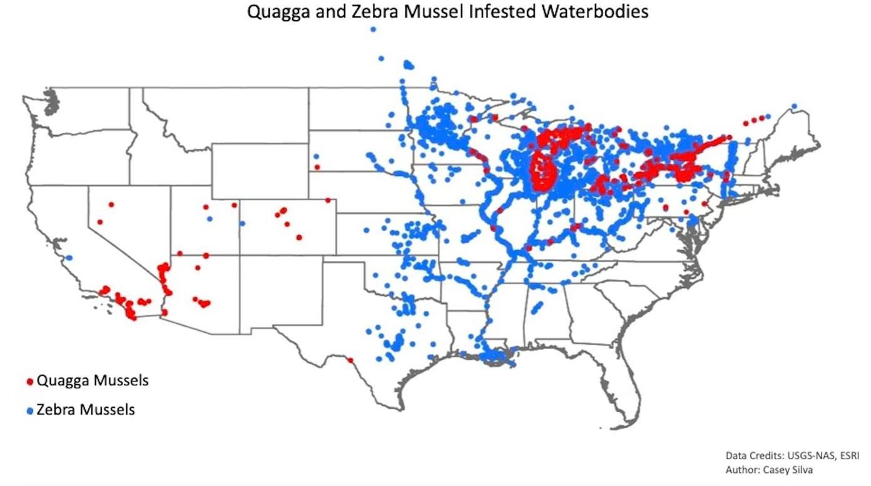

Figure 6. Bodies of water that are currently infested with quagga and zebra mussels (see Appendix A and Appendix B for data amendments) (Benson et al., 2022(1)) and (Benson et al., 2022(2)).

Though both species shared a similar pattern of spread, there are noticeable differences when infestation is broken down my time period.

Zebra mussel

Arriving in 1986, the first few years of zebra mussel infestation were concentrated around the Midwest and Northeast (Figure 7).

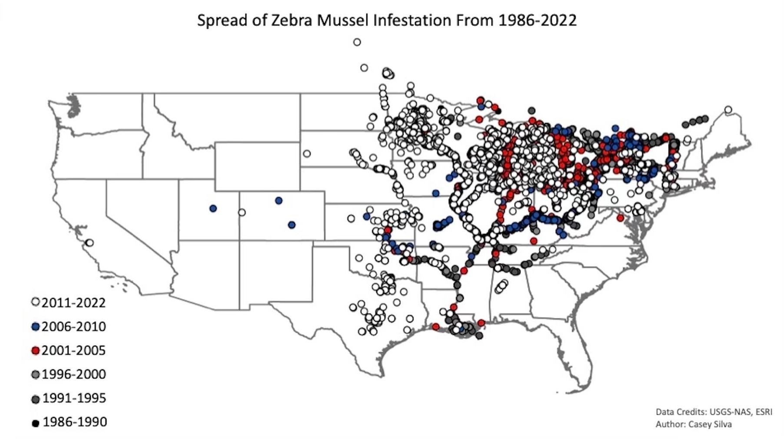

Figure 7. The progressive spread of zebra mussels across the United States, broken down by year(see Appendix A for data amendment) (Benson et al., 2022(1)).

From 1991 to 2000 zebra mussels traveled down the Mississippi River, ultimately ending in Louisiana where the Mississippi joins the saltwater of the Gulf of Mexico. By 2010, when research on this species finally made headlines, nearly the entire east had been infested. In last decade zebra mussels have continued their takeover of the Midwest and the east, where agencies knew eradication was nearly impossible, so prevention programs were never established. There is a solid delineation of infested waterbodies where the Midwest reaches the west, with only a few mussels making it past this defense point (Table 4) (see Appendix A for a data amendment) (Benson, et al., 2022(1)).

| **State** | **Infested Waterbodies** | **Total HUC’s** |
| --- | --- | --- |
| **California** | San Justo Reservoir | 1 |
| **Colorado** | Highline Lake | 1 |
| **North Dakota** | Red River (lower, middle, and upper), Sheyenne River, Twin Lakes,  Cottonwood Creek, Lake Elsie | 7 |
| **South Dakota** | Missouri River, Whetstone Bay, Snake Creek, Platte Creek, Pease  Creek, American Creek, Lake Cochrane, McCook Lake, Lake Mitchell, Pactola Reservoir, Lake Kampeska, Enemy Swim Lake | 6 |

Table 4. Western states and US bodies of water that are currently infested with zebra mussels (Benson et al., 2022(1)). The HUC value is defined as Hydrologic Unit Codes, or how many watersheds are affected by infestation (*Hydrologic Unit Codes (HUC’s) Explained,* n.d.).

Quagga mussel

Transported by a ship whose ballast water was collected near Russia, quagga’s introduction came to the Great Lakes in 1989 (Figure 8) (*Quagga and Zebra Mussels Invasive Species in the Great Lakes,* n.d.).

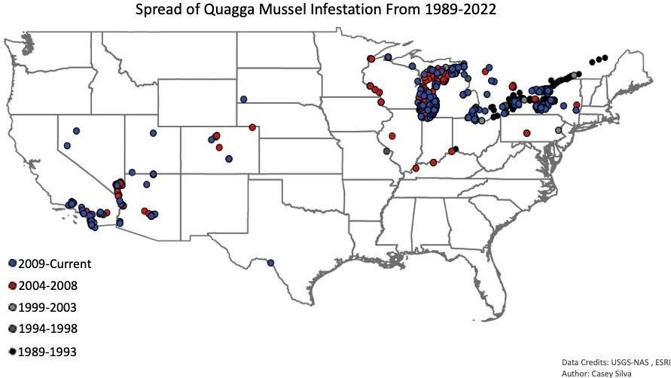

Figure 8. The progressive spread of quagga mussels across the United States, broken down by year (see Appendix B for data amendment) (Benson et al., 2022(2)).

Zebra mussels had already established populations in the majority of close-by waterways, leaving quagga at a disadvantage for invasion. It wasn’t until 2004 that quagga started to spread outside it’s initial regions. Unlike zebra mussels, quagga has successfully

penetrated the west with infestations in California, Arizona, Nevada, Colorado, and Utah (Table 5) (Benson, et al., 2022(2))(see Appendix B for data amendments).

| **State** | **Infested Waterbodies** | **Total HUC’s** |
| --- | --- | --- |
| **Arizona** | Lake Pleasant, Lake Havasu, Lake Mojave, Imperial Reservoir, Martinez Lake, Lake Mead, Mittry Lake, Colorado River- Marble  Canyon, Lower Lake Powell, Salt River, Red Mountain Park Lake | 10 |
| **California** | Lake Havasu, Lake Mojave, Imperial Reservoir, Lake Forest, Rattlesnake Reservoir, Coachella Canal, Sweetwater Reservoir, San Vicente Reservoir, Murray Reservoir, Lower Otay Lake, Lake Ramona, Lake Poway, Lake Miramar, Lake Jennings, El Capitan Reservoir, San Gabriel River, Anaheim Lake, Kraemer Basin, Dixon Reservoir, Olivenhain Reservoir, Irvine Lake, Walnut Canyon Reservoir, Lake Mathews, Santa Clara River, Piru Creek, Lake Piru, Pyramid Lake, Elderberry Forebay, Castaic Lake, Angeles Tunnel, Santa Margarita River, Skinner Reservoir, Lake Cahuilla, Shadow  Lake | 12 |
| **Colorado** | Green Mountain Reservoir, Grand Lake, Lake Granby, Shadow Mountain Reservoir, Willow Creek Reservoir, Jumbo Lake, Tarryall  Reservoir, Pueblo Reservoir | 5 |
| **Montana** | Colorado River, Lake Havasu, Lake Mojave, Lake Mead, Rye Patch Reservoir- Humboldt River, Lahontan Reservoir- Carson River | 4 |
| **South Dakota** | Cheyenne River | 1 |

Table 5. Western states and US bodies of water that are currently infested with quagga mussels (Benson et al., 2022(2)). The HUC value is defined as Hydrologic Unit Codes, or how many watersheds are affected by infestation (*Hydrologic Unit Codes (HUC’s) Explained,* n.d.).

The low number of zebra populations in the west didn’t provide any species competition, therefore when quagga were unintentionally introduced, the population developed with ease. The 2007 quagga infestation of Lake Mead was the first established population to be confirmed in the west. It was also the first time an ecosystem of significant size was infiltrated by quagga without an existing zebra infestation (Wong & Gerstenberger, 2011). Shortly after, quagga did it again with the 2013 infestation of Lake Powell.

*Ecological Impacts*

Mussel infestations have proven to be prolific due to the domino effect their way of life has on an ecosystem. The ecological impacts of quagga and zebra infestations extend to aquatic plants, native organisms, and water quality. Beginning at the bottom of the food chain, rapid filtration rates remove vital chlorophyll, nutrients, and phytoplankton from the water column, in turn decreasing primary production. Less phytoplankton means a decreased food source for all filter feeding invertebrates. The Great Lakes has suffered a dramatic loss of native amphipods, mollusks, and chironomids (Karatayev et al., 2014). This decrease in invertebrate

populations has affected small fish species (Hoddle, 2022). The lack of floating particles in the water column creates deeper light penetration and visibility under the surface. Many studies in North America and Europe have attributed the rise in dangerous algal blooms, such as cyanobacteria, to quagga and zebra mussel filtration. (Karatayev et al., 2014). While the toxic algae concentrations rise, native vegetation is outcompeted for space and nutrients. Sparse vegetation means fewer spawning areas for fish species and habitats for benthic organisms.

While visual fish predators are positively affected by mussel infestation due to increased visibility, larval fish are subject to higher predation rates, preventing successful reproduction and population growth. (Karatayev et al., 2014).

A study conducted in the Hudson River showed a decrease of phytoplankton biomass by 85% after infestation (Benson et al., 2022(1)). The alteration of these natural ecosystem properties resulted in a decline in pelagic fish volume and their growth rates (Karatayev et al., 2014). The profundal zone of the Great Lakes is suffering from a similar tragedy, the decline in *Coregonus clupeaformis* (whitefish), alewife, and sculpin populations as a result of the amphipod *Diporeia* population decreasing. The domino effect shows itself in this food chain, where the declining fish species listed above are prey for larger fish such as salmon and trout (Karatayev et al., 2014).

After filter feeding, the mussels release particles in the form of pseudofeces; mucus covered droppings that expel excess nutrients. The accumulation of pseudofeces in benthic environments can lead to an array of water quality issues. Large amounts of carbon, nitrogen, and phosphorus decrease dissolved oxygen concentrations and can lead to eutrophic waters (Lin & Zhang, 2015). The water clarity mussel filtration creates partnered with high concentrations of nutrients and organic matter is another manner in which toxic algal blooms can form.

Although mussel infestation has had dramatic impacts in many aquatic systems, a few isolated incidents have reached national headlines in the United States. Since 1999 the Great Lakes has seen tens of thousands of fish-eating-birds die of avian botulism. This disease emerges periodically with massive die-offs as the consequences, but zebra and quagga mussel infestations have accelerated this cycle. The bioaccumulation of toxins in the tissue of mussels

can be 300,000 times that of the waters they are living in (Hoddle, 2022). Invasive round goby is one of the mussel's only predators in the Great Lakes. When goby consumes the mussels, then the birds prey on the goby, this alarming level of toxins is biomagnified up the food chain ultimately resulting in avian botulism. Many bird species residing in the Great Lakes are listed as threatened or protected, therefore mass die-offs due to avian botulism are having a significant effect on the individuals left (Hochanadel, 2021).

February 2021 brought a new battle when adult zebra mussels were discovered in

“moss balls”, the newest craze in aquarium pets. A press release was broadcasted by the USGS immediately upon discovery, urging buyers of the product to check their aquariums. Many

Members of the public who aren’t actively involved in the recreation, fishing, or boating communities have no knowledge of the mussel epidemic and state and federal agencies feared this would be the event to infest the remainder of the United States. By April 27, 2021, zebra infested moss balls had been identified in 46 states (National Invasive Species Information Center, n.d.). On May 8, 2021, the U.S. Fish & Wildlife Service (USFWS) announced Wyoming, Arizona, Alaska, Oregon, Hawaii, and North Dakota had placed agricultural quarantines on moss balls. The U.S. Department of Agriculture, USFWS, Pet Industry Joint Advisory Council as well as state wildlife agencies began collaboration on how to target the issue. Knowledge of zebra mussel’s microscopic larval stage was broadcasted to educate the public that “just because they didn’t see a mussel, didn’t mean they wouldn’t show up eventually.” Proper disposal methods were directed to all purchasers of the moss balls (USFWS, n.d.). Wildlife agencies were attentive to this issue and continue to monitor any potential consequences that could arise.

*Recreational Impacts*

Utah’s slogan speaks for itself: “The Outdoor Playground of the West”. Home to five national parks and 44 state parks, millions of people travel to Utah each year to experience all it has to offer. Utah residents spend the summers swimming, boating, and fishing between lakes and reservoirs. The newly developed Utah Division of Outdoor Recreation states the outdoor recreation industry creates $737 million in state and local tax revenues and provides $3.2 billion

in wages and salaries annually (*Utah Division of Outdoor Recreation,* 2022). A quagga or zebra infestation could cause a significant increase in recreation opportunities.

Lake Powell is still one of the most frequented bodies of water by Utah residents and interstate travelers. Quagga mussels have provided crystal clear water perfect for boating and swimming, but at a cost. Visitors tolerate pungent smells from decaying mussels when the water levels decrease and occasional injury from the sharp shells that cover the beaches. Many boaters have resorted to staying on their vessels and avoiding the beaches all together. While in the water, vessels are at risk of motor damage, clogged interior systems, and cosmetic issues from mussel attachment. The severity of these damages is dependent on how long the vessel is in the water. A survey taken from Lake Erie boat owners stated recreational vessels had on average $600 worth of maintenance and repairs attributed to mussel infestation (*Dreissena polymorpha*, 2021). After removing vessels from the water, boaters then endure the inspection or decontamination process, which can be time consuming during peak season. These are just a few reasons why some residents have decided that Lake Powell isn’t worth the hassle anymore.

Depending on the severity of the infestation and resources the agency has available, some bodies of water are at risk of complete closure if quagga or zebra were to emerge. The costly process of managing a containment program requires support from the public and the personnel to operate it. If these factors aren’t obtainable, the loss of an outdoor recreation opportunity is likely.

Utah is home to many blue-ribbon sport fisheries that are enjoyed by both resident and non-resident anglers. The UDWR operates a diligent fisheries program that consistently stocks lakes and reservoirs with sought after catches. The Tiger Muskie, a sterile cross between the Northern Pike and Musky, is a trophy catch at the center of many tournaments and contests.

Tiger Muskie aren’t a standard species, making these experiences unique and desirable. The effect a mussel infestation would have on Tiger Muskie has not been studied, but it’s inferred the population would decline due to the stress mussels would cause on the species Muskie prey upon (i.e., perch, blue gill, crappie).

*Agricultural and Municipal Water Impacts*

When the western United States began development, it implemented different strategies of water use and distribution than the east had been operating. Eastern waters are city/district-based, with large operation centers and intricate means of transporting water to various locations. In the west it is still standard for homes in smaller towns to use wells. The majority of municipal and agricultural water in the west comes from lakes and reservoirs.

Quagga and zebra mussels would not only cause significant damage to pipes, treatment plants, and dams, but the water would need to undergo extensive treatments before it could be distributed.

The agriculture industry represents the largest employment category in Utah. With a $1 billion livestock industry, Utah’s economy depends on functional water resources to support farming (*About UDAF* | *Utah Department of Agriculture and Food,* 2022). Pineview Reservoir in Ogden, UT provides water to a surrounding 298 square miles, much of that being farmland. To reach recipients on demand, water travels through Pineview’s infrastructure system at 2300 cubic feet per second. With the known densities of mussel populations, clogged pipes would need consistent work to maintain this delivery speed (*Pineview Dam*, n.d.).

These additional efforts to maintain water quality and deliverance are costly. This would mean an increase in water cost and state taxes for residents. Montana’s Department of Natural Resources estimated an annual $47 million dollars in water infrastructure repairs should an infestation emerge (Char-Koosta News, 2021).

*Policy*

Similar to Utah’s laws and codes, all western states have established policies against the

transport and possession of invasive mussels. Idaho Administrative Code under the Department of Agriculture closely mimics Utah’s, requiring proof of inspection and decontamination and drain plug removal (The Idaho Invasive Species Act, 2008). Montana Fish, Wildlife & Parks has implemented the most severe punishments for AIS violations in their state. They didn’t have any AIS legislature until 2015. Montana issues a felony charge with a fine up to $5,000 “if you knowingly or purposely attempt to introduce AIS into Montana waters. They also issue citations

for inspection and decontamination violations (Agriculture, 2015). California is an interesting case where AIS laws are enacted by both Fish and Game Code and California Code of Regulations (*Laws and Regulations Regarding Invasive Species,* 2022). As technology improves and mussel research reaches new findings, all states amend their rules and regulations to ensure complete legal protection from a mussel infestation, and that consequences are issued to those not in compliance.

Federal agencies have regulations in place against AIS as well. The Lacey Act of 1900 broadly began AIS legislation, prohibiting the “importation, exportation, transportation, sale, or purchase of fish and wildlife taken or possessed in violation of State, Federal, Indian tribal, and foreign laws.” (The Lacey Act, 1900). The next piece of legislation passed was an Executive Order by President Jimmy Carter “restricting the introduction of exotic species into the natural ecosystems on lands and waters which they own, lease, or hold for purposes of administration; and, shall encourage the States, local governments, and private citizens to prevent the introduction of exotic species into natural ecosystems of the United States.” (Exec. Order No.

11987, 1977). USFWS passed the Nonindigenous Aquatic Nuisance Prevention and Control Act of 1990 in response to the quagga and zebra introduction in the Great Lakes. The National Invasive Species Act of 1996 amended the 1990 act in an attempt to better manage the expelling of ballast water to prevent further mussel spread and new species from being introduced through the same pathway (National Invasive Species Act of 1996, 1996). Legislation made major headway in 1999 when President Clinton signed Executive Order 13112 into effect. The order established the National Invasive Species Council, the first federal organization responsible for overseeing invasive species infestations and coordinating between states, tribal councils, and environmental agencies (Exec. Order No. 13112- Invasive Species, 1999). Similar to state legislation, federal acts are amended when necessary to include new findings about mussel infestation and new technology that could assist in stopping their spread.

*Financial Impacts and Monetary Predictions*

Increased taxes, boat repairs, and water infrastructure maintenance are the primary costs a mussel infestation would create for a Utah state resident. The brunt of the expense if

quagga or zebra established populations in Utah would become the responsibility of the state government and environmental agencies. In an interview with Bruce Johnson, the AIS statewide operations lieutenant, he explained that 87% of the funding for Utah’s AIS program is derived from government allocated monies, which are a combination of taxpayer dollars and grant funds provided by state and federal governments. The remainder of funding is split between boater registration fees and UDWR hunting/fishing license sales.

Lake Powell AIS operations on the Utah side fall within the boundaries of Glen Canyon National Recreation Area, managed by the National Park Service (NPS). UDWR still funds a

portion of Powell’s containment program, but some operation monies are supplied by NPS. Following the infestation of Lake Mead, Powell’s close neighbor, NPS began an aggressive mussel prevention program. Between 2000 and 2013 NPS spent $7.5 million on AIS prevention measures at Lake Powell alone (National Park Service, 2018). This number annually escalates as more infestation-related issues arise.

Lake Mead and its surrounding community spends over $20 million annually to combat mussel infestations (*About AIS- Aquatic Invasive Species* | *Tahoe Boat Inspections,* n.d.).. An estimation provided for power plant, water systems, and industrial complexes maintenance in the Great Lakes region stated over $500 million are spent each year (Hoddle, 2022). Though different environments would result in different outcomes/issues, many western states have provided estimates to the general public on what a mussel infestation could cost their state or region based on numbers provided by currently infested states.

The Montana Department of Natural Resources estimates $234 million worth of economic damages annually due to infestation. The department divided this loss into three categories: $122 million in recreation impacts, $61 million in agricultural losses, and $47 million in necessary infrastructure repairs and replacements (Char-Koosta News, 2021). The state of Washington has also predicted monetary values in the hundreds of thousands should they run across infestation issues (*Zebra & Quagga Mussels,* 2022). The Army Corps of Engineers provided an estimate of $22 million annually to the Lake Tahoe region of California alone. They reached this value based on damage to the tourism industry, a decrease in property values, and elevated maintenance costs (Hoddle, 2022). Utah shares similar ecosystem characteristics,

recreation opportunities, and water distribution structures as these western states. This concludes that further quagga or zebra infestation in Utah would create the need for an elevated budget, an increase in personnel to handle infestation consequences, and new policy to transition from a prevention program to a containment program.

# Discussion

Utah’s AIS efforts speak for themselves when comparing data to other states. Invasive species technicians employed by Idaho’s Invasive Species Fund program, managed by The Idaho Department of Agriculture, inspected 113,733 vessels in 2021, a little over a third of Utah’s boater interviews (*Maps,* 2021). Montana’s Fish, Wildlife, and Parks department manages their AIS program. Their 2021 annual report recorded 123,311 inspections (*Watercraft Inspection Report 2021,* 2021). Utah’s AIS program reaches more people, uses newer technology, and implements law enforcement in unique ways compared to other states.

Further infestation to Utah would cause significant damage, some of which cannot be repaired. Ecological impacts of mussel infestation would alter native ecosystems and potentially lead to an eradication of species already under biological stress. With native fisheries and

aesthetic environments drawing peoples’ interest to visit Utah, the complications a quagga or zebra infestation creates when it comes to recreating would make Utah water bodies less attractive places to explore. Added complexity to water systems and distribution would not only affect those employed in the agriculture industry, but every residence with running water. A decline in revenue from the recreation and agriculture industries would have a statewide economic impact.

As these prolific mussels continue to make headlines, the general public gains knowledge on what the environment and the economy are up against. The best way to prevent the spread of mussels is to continue to educate the public nationwide on what is at stake if they further invade. Both state and federal agencies will update statutes, administrative codes, and laws when developments arise in the AIS world. Strong interagency collaboration and communication is the best chance at saving the remainder of Utah from an infestation that would change all aspects of the state forever.

# Literature Cited

*About AIS- Aquatic Invasive Species* | *Tahoe Boat Inspections.* (n.d.). https://[www.tahoeboatinspections.com/tahoe-keepers/about-ais/.](http://www.tahoeboatinspections.com/tahoe-keepers/about-ais/)

*About UDAF | Utah Department of Agriculture and Food.* (2022, February 15). https://ag.utah.gov/about/.

Act For Libraries. (2017, January). *Quagga and Zebra Mussels Invasive Species in the Great Lakes*. <http://www.actforlibraries.org/quagga-and-zebra-mussels-invasive-species-in-> the-great-lakes/.

Agriculture, 80 § Chapter 7 Part 10: Aquatic Invasive Species (2015). https://leg.mt.gov/bills/mca_toc/80_7_10.htm.

Aquatic Invasive Species Interdiction Act, 23 Utah Code § 27 (2008). https://[www.le.utah.gov/xcode/Title23/Chapter27/C23-27_1800010118000101.pdf.](http://www.le.utah.gov/xcode/Title23/Chapter27/C23-27_1800010118000101.pdf)

Aquatic invasive species interdiction, Utah Administrative Rule R657-60 (2021). https://wildlife.utah.gov/index.php/r657-60.html.

1. Benson, A.J., Raikow, D., Larson, J., Fusaro, A., Bogdanoff, A.K., and Elgin, A. (2022). *Dreissena*

*polymorpha* (Pallas, 1771): U.S. Geological Survey, Nonindigenous Aquatic Species Database, Gainesville, FL. https://nas.er.usgs.gov/queries/FactSheet.aspx?speciesID=5.

1. Benson, A.J., Richerson, M.M., Maynard, E., Larson, J., Fusaro, A., Bogdanoff, A.K., Neilson, M.E., and Ashley Elgin. (2022). *Dreissena bugensis* Andrusov, 1897: U.S. Geological Survey, Nonindigenous Aquatic Species Database, Gainesville, FL. https://nas.er.usgs.gov/queries/FactSheet.aspx?SpeciesID=95.

Char-Koosta News. (2021, October 12). *Cost of a quagga and zebra mussel infestation.* Great Lakes Now. https://[www.greatlakesnow.org/2021/05/cost-quagga-zebra-mussel](http://www.greatlakesnow.org/2021/05/cost-quagga-zebra-mussel) infestation/.

DWR. (2022, May 9). *Boaters should stop at the Evanston Port of Entry for aquatic invasive species inspections before going to Bear Lake, Flaming Gorge.* https://[www.wildlife.utah.gov/news/utah-wildlife-news/1426-boaters-should-stop-at](http://www.wildlife.utah.gov/news/utah-wildlife-news/1426-boaters-should-stop-at) evanston-port-of-entry-for-aquatic-invasive-species-inspections-before-going-to-bear lake-or-flaming-gorge.html.

*Dreissena polymorpha.* (2021). Smithsonian Environmental Research Center. https://invasions

.si.edu/nemesis/species_summary/81339.

Egan, Dan. (2019, January 2). *Zebra Mussels’ Takeover of the Great Lakes.* Discover Magazine. https://[www.discovermagazine.com/environment/zebra-mussels-takeover-of-the-](http://www.discovermagazine.com/environment/zebra-mussels-takeover-of-the-) great-lakes.

Exec. Order No. 11987, 3 C.F.R. 116 (1977). https://[www.invasivespeciesinfo.gov/executive-](http://www.invasivespeciesinfo.gov/executive-) Order-11987.

Exec. Order No. 13112- Invasive Species, Volume 64, Number 25 (1999). https://[www.invasivespeciesinfo.gov/executive-order-13112.](http://www.invasivespeciesinfo.gov/executive-order-13112)

Hochanadel, D. (2021, November 10). *Invasive mussels may worsen avian botulism outbreaks.*

Lake Scientist. https://[www.lakescientist.com/invasive-mussels-may-worsen-avian-](http://www.lakescientist.com/invasive-mussels-may-worsen-avian-) botulism-outbreaks/.

Hoddle S., Mark. (2022, January). *Quagga & Zebra Mussels.* UC Riverside Center for Invasive Species Research. https://cisr.ucr.edu/invasive-species/quagga-zebra-mussels.

*Hydrologic Unit Codes (HUC’s) Explained.* (n.d.). U.S. Geological Survey, Nonindigenous Aquatic Species Database. https://nas.er.usgs.gov/hucs.aspx.

Karatayev, A.Y., Burlakova, L.E. & Padilla, D.K. Zebra versus quagga mussels: a review of their Spread, population dynamics, and ecosystem impacts. *Hydriobiologia* **746**, 97-112 (2015). https://doi.org/10.1007/s10750-014-1901-x.

*Laws and Regulations regarding Invasive Species.* (2022). California Department of Fish and Wildlife. https://wildlife.ca.gov/Conservation/Invasives/Regulations.

Lin, C., & Zhang, L. (2015). *Pseudofeces.* Science Direct. https://www.science direct.com/topics/ veterinary-science-and-veterinary-medicine/pseudofeces.

National Invasive Species Act of 1996, Pub. L. No. 104-332, 26 Stat. 417 (1996). https://[www.govinfo.gov/app/details/PLAW-104publ332/summary.](http://www.govinfo.gov/app/details/PLAW-104publ332/summary)

National Invasive Species Information Center. (n.d.). *Zebra Mussels Found in Aquarium Moss Balls | National Invasive Species Information Center.* U.S. Department of Agriculture. https://invasivespeciesinfo.gov/zebra-mussels-found-aquarium-moss-balls.

National Park Service. (2018). *Mussel Frequently Asked Questions- Glen Canyon National Recreation Area (U.S. National Park Service).* https://[www.nps.gov/glca/learn/nature](http://www.nps.gov/glca/learn/nature)

/mussel-frequently-asked-questions.htm.

*Pineview Dam.* (n.d.). Bureau of Reclamation. https://[www.usbr.gov/projects/index.php?id=218.](http://www.usbr.gov/projects/index.php?id=218)

Stop Aquatic Hitchhikers!. (n.d.). *Quagga and Zebra mussel* [Photograph]. Google Images. https://stopaquatichitchhikers.org/hitchhikers/mollusks-zebra-mussel/.

Tennessee Wildlife Resources Agency. (n.d.). *Zebra Mussel* [Photograph]. Google Images. https://[www.tn.gov/twra/fishing/twra-fish-species/zebra-mussel.html.](http://www.tn.gov/twra/fishing/twra-fish-species/zebra-mussel.html)

The Idaho Invasive Species Act, 22 § Chapter 22 (2008). https://legislature.idaho.gov/statutes rules/idstat/Title22/TT22CH19/.

The Lacey Act, 18 U.S.C. § 42 (1900). https://fws.gov/law/lacey-act-amendments-1981.

Texas Invasive Species Institute. (2014). *Quagga Mussel* [Photograph]. Google Images. [http://www.tsusinvasives.org/home/database/dreissena-bugensis.](http://www.tsusinvasives.org/home/database/dreissena-bugensis)

USFWS. (n.d.). *Invasive Zebra Mussels Found in Moss Balls.* U.S. Fish & Wildlife Service. https://fws.gov/story/invasive-mussels-found-in-moss-balls.

*Utah Division of Outdoor Recreation.* (2022). https://recreation.utah.gov/. Utah Division of Wildlife Resources. (2022). Aquatic Invasive Species in Utah.

https://stdofthesea.utah.gov.

Wong, W.H., & Gerstenberger, S. (2011). Quagga Mussels in the Western United States: Monitoring and Management. *Aquatic Invasions*, *6*(2), 125-129. https://doi.org/10.3391/ai.2011.6.2.01.

*Zebra and Quagga Mussels.* (2022, May 11). Invasive Species Council. https://invasivespecies.wa.gov/priorityspecies/zebra-and-quagga-mussels/.

# Appendix A

Data points from U.S. Geological Survey’s Nonindigenous Aquatic Species Database used to make these maps have not been updated since 2021. It displays points for zebra infestations in Utah, where they have since been proven to be false.

# Appendix B

Data points from U.S. Geological Survey’s Nonindigenous Aquatic Species Database used to make these maps have not been updated since 2021. It displays points for quagga infestations in Utah, where they have since been proven to be false.